|  |  |  |
| --- | --- | --- |
| **Guide Name** | | **Panel Head** |
|  | Mrs Jayapradha J | Dr.M.Baskar |
|  |  |  |
|  | **Faculty Advisor** | **Project Domain** |
|  | Dr.K.Alice | Machine Learning |
| M |  |  |
|  | **Student(s) Details: Name** | **Passport size photo(s)** |
|  | 1. Bathala Vishal 2. Adit Mahajan |  |
|  |  |  |

Registration Number(s)

1. RA1911003010495

2. RA1911003010497

**Email ID(s)&Mobile Number(s)**

|  |  |
| --- | --- |
| 1: bv9209@srmist.edu.in | 2: am6504@srmist.edu.in |
| 9121338238 | 8925614488 |

**Abstract Architecture Diagram**

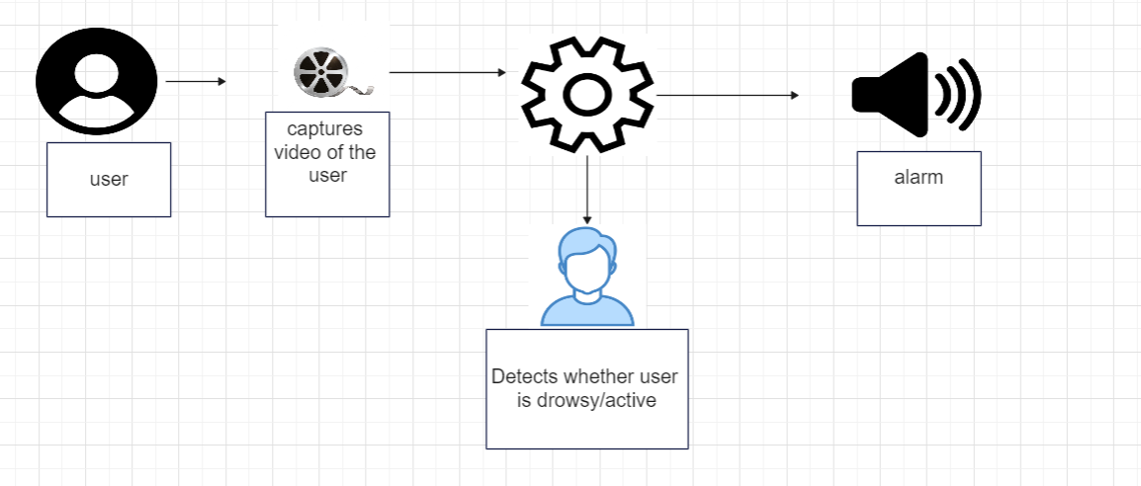

Nowadays the driver safety in the car is one of the most wanted system to avoid accidents. Our objective of the project is to ensure the safety system. For enhancing the safety, we are detecting the eye blinks of the driver and estimating the driver status and control the car accordingly.The main idea behind this project is to develop a nonintrusive system, which can detect fatigue of any human and can issue a timely warning. Drivers who do not take regular breaks when driving long distances run a high risk of becoming drowsy a state that they often fail to recognize early enough.This system will monitor the driver eyes using a camera and by developing an algorithm we can detect symptoms of driver fatigue early enough to avoid the person from sleeping. Therefore, this project will be helpful in detecting driver drowsiness in advance and will give warning output in form of alarm sound Drowsiness Detection System (DDS) is an efficient system.

**Significance of the Project Conclusion**

Our objective of the project is to ensure the safety system.For enhancing the safety, we are detecting the eye blinks of the driver and estimating the driver status and control the car accordingly.This system will monitor the driver’s eyes using a camera and by developing an algorithm we can detect symptoms of driver fatigue early enough to avoid the person from sleeping

We were successful in attaining an accuracy score of 93.7%, which is higher than the majority of the other models. While previous models were either constructed on hardware or based on some other models with less accuracy, we were able to attain this level of accuracy by using the ideas of deep learning. Because the hardware is mounted to the driver itself, using capacitive sensors may be exceedingly unpleasant and aggravating for the user. Earlier versions, on the other hand, were constructed using resistive sensors.

**Conference/Journal Publication Details (If Any)**